# CS 255 System Design Document Template

This template lays out all the different sections that you need to complete for Project Two. Each section has guidance to prompt your thinking. You will need to continually reference the interview transcript as you work to make sure that you are addressing your client’s needs. There is no required length for the final document. Instead the goal is to complete each section based on what your client’s needs are. Remove this note when you are finished, and replace all bracketed text with the relevant information.

## UML Diagrams

### UML Use Case Diagram

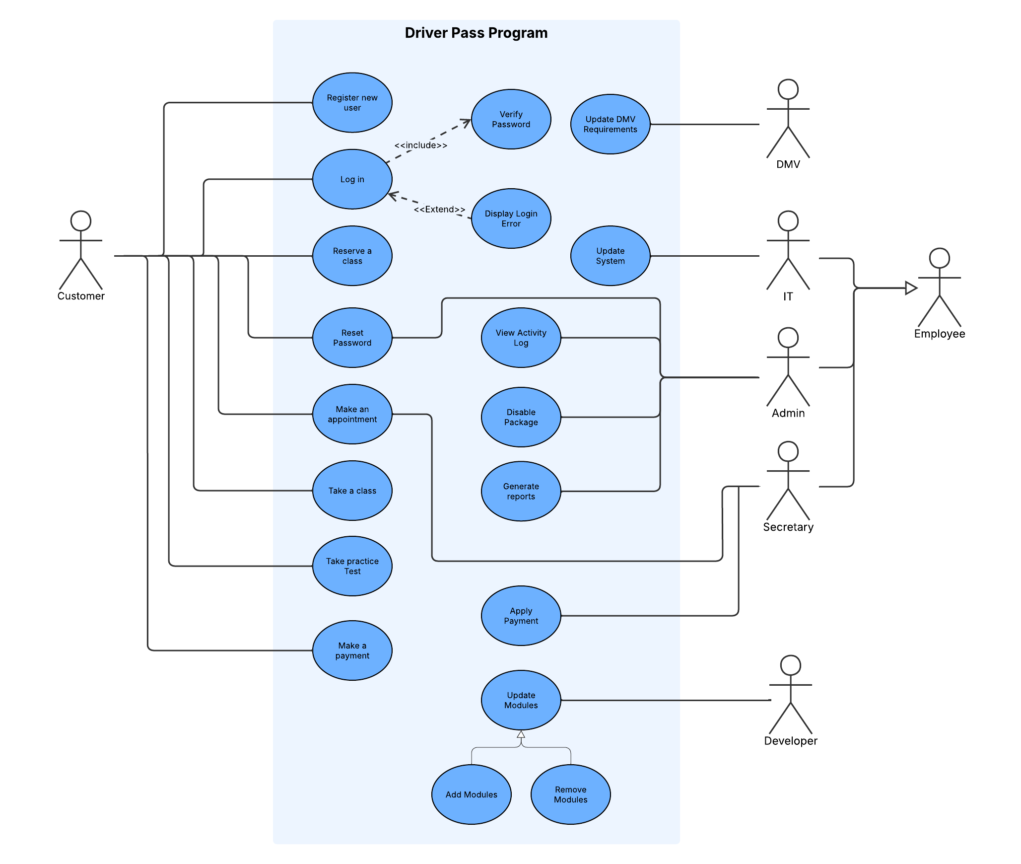

### UML Activity Diagrams

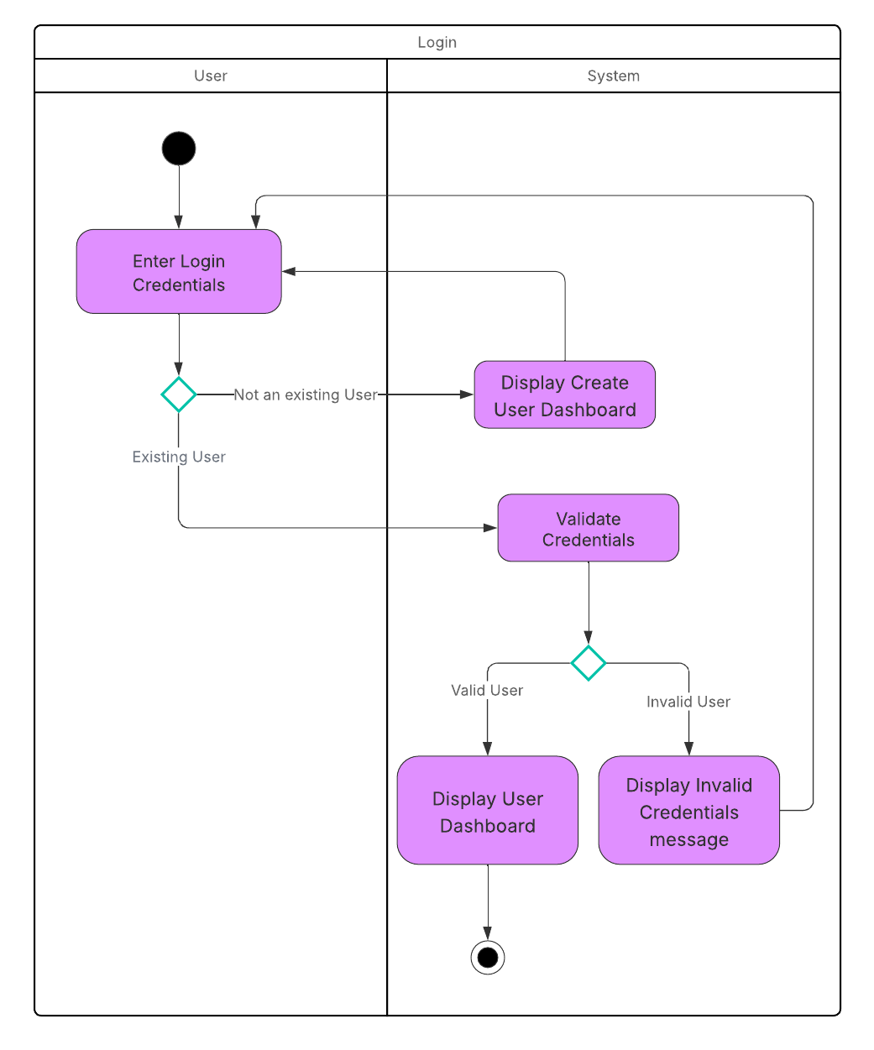

### UML Sequence Diagram

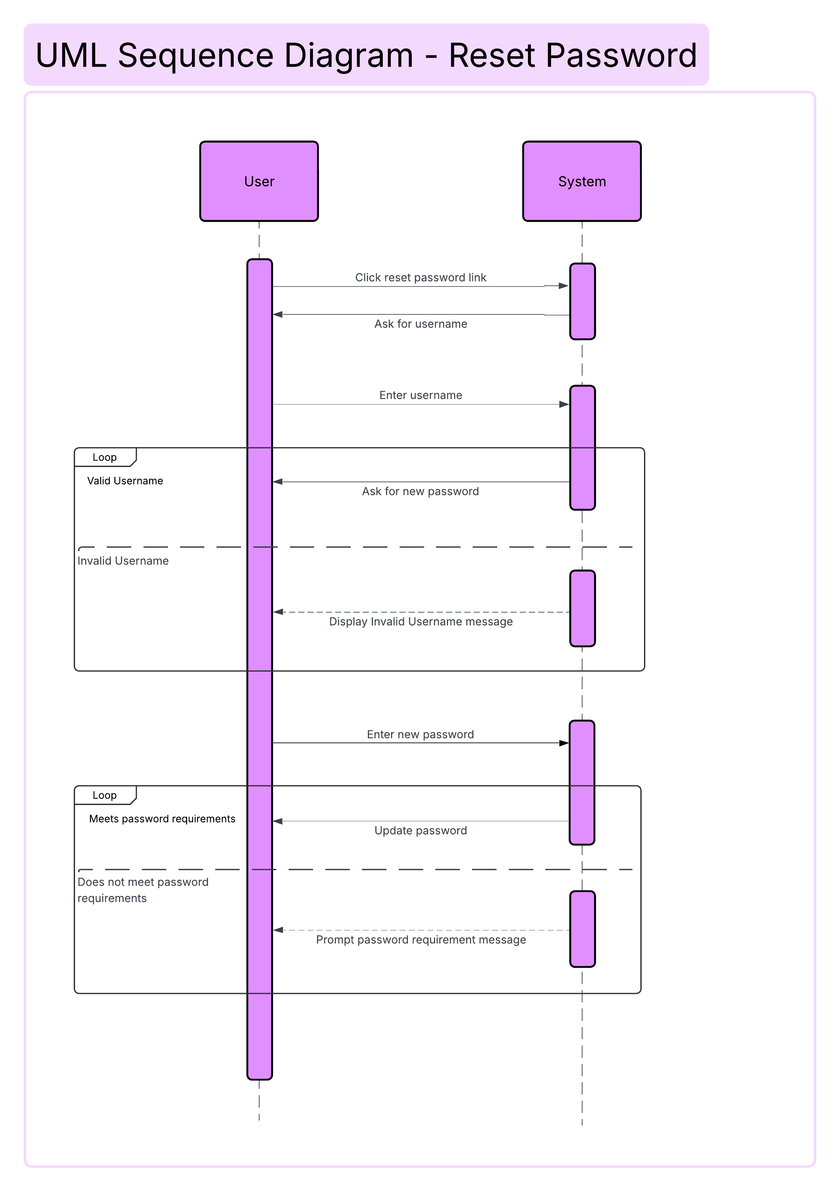

### UML Class Diagram

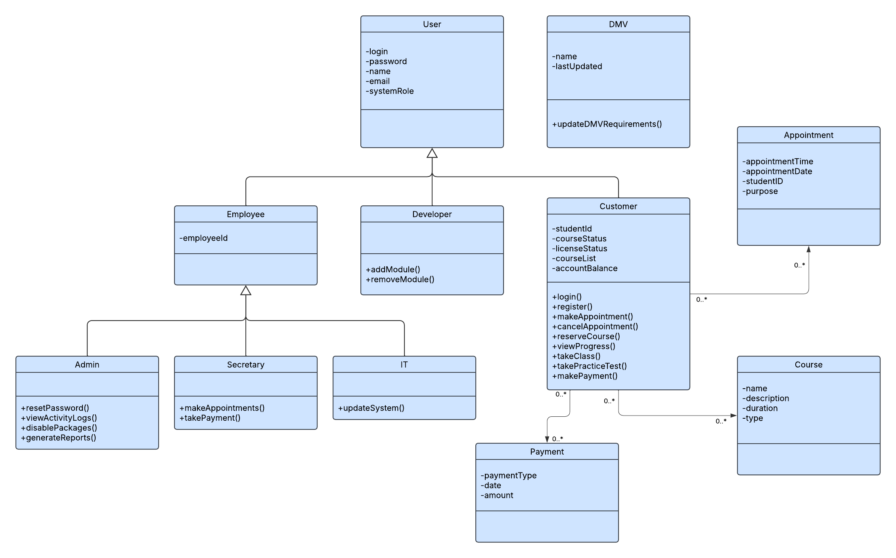

## Technical Requirements

As a web-based application this system would require several components for the system’s architecture, a web server, a relational database, a hosting service, such as AWS, that will house the application and an integration for the DMV API. For security we would use HTTPS and keep packages up to date. The software needed to access the application is a browser: Modzilla, Firefox, Chrome, Safari, Brave. For frontend development we would need to use an IDE such as PyCharm, Webstorm. Or a similar IDE that allows for development and testing HTML, JavaScript and CSS.